Singing with Children

An Old Woman who swallowed a fly
There was an old woman who swallowed a fly,
I don’t know why she swallowed a fly,
Perhaps she’ll die.

There was an old woman who swallowed a spider,
That wriggled and jiggled and tickled inside her,
She swallowed the spider to catch the fly,
I don’t know why she swallowed the fly,
Perhaps she’ll die.

There was an old woman who swallowed a bird,
How absurd! to swallow a bird,
She swallowed the bird to catch the spider,
She swallowed the spider …

There was an old woman who swallowed a cat,
Imagine that! to swallow a cat,
She swallowed the cat to catch the bird,
She swallowed the bird…

There was an old woman who swallowed a dog,
What a hog! to swallow a dog,
She swallowed the dog to catch the cat,
She swallowed the cat …

There was an old woman who swallowed a goat,
Just opened her throat! to swallow a goat,
She swallowed the goat to catch the dog,
She swallowed the dog …

There was an old woman who swallowed a cow,
I don’t know how she swallowed a cow!
She swallowed the cow to catch the goat,
She swallowed the goat …

There was an old woman who swallowed a horse,
She’s dead—of course!

Cindy Lauper (recitation and animation) http://youtube.com/watch?v=bHcx7ufVK0o
Judy Collins on the Muppet Show: http://youtube.com/watch?v=YPAGJgCsFWY&feature=related

Going To The Zoo
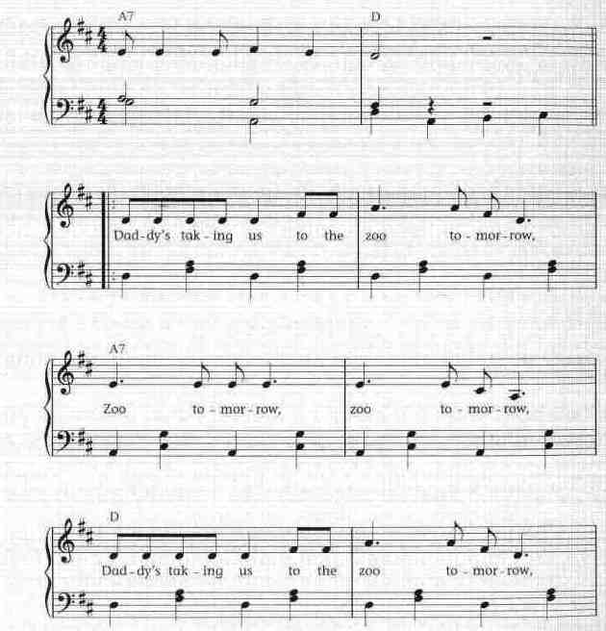
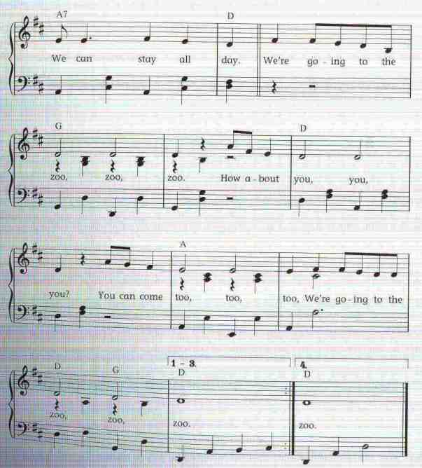

Daddy’s takin’ us to the zoo tomorrow,
zoo tomorrow, zoo tomorrow
Daddy’s takin’ us to the zoo tomorrow
and we can stay all day!

We’re goin’ to the zoo, zoo, zoo
How about you, you, you?
You can come too, too, too
We’re goin’ to the zoo, zoo, zoo.

See the elephant with the long trunk swingin’
Great big ears and a long trunk swingin’
Snuffin’ up peanuts with a long trunk swingin’
And we can stay all day!

See all the monkeys they’re scritch-scritch scratchin’
jumpin’ around and scritch-scritch scratchin’
Hangin’ by the long-tail (huff huff huff)
And we can stay all day!

There’s a big black bear he’s a huff-puff-a-puffin’
His coat’s too heavy he’s a huff-puff-a-puffin’
Don’t get too near the huff-puff-a-puffin’
Or you won’t stay all day!
Well the seals in the pool all honk-honk-honkin’
Catchin’ the fish and honk-honk-honkin’
Little tiny seals all honk-honk-honkin’
And we can stay all day!

Well we stayed all day and I’m gettin’ sleepy
Sittin’ in the car gettin’ sleep sleep sleepy
Home already gettin’ sleep sleep sleepy
‘Cause we have stayed all day.

We been to the zoo zoo zoo
So have you you you
You came too too too
We been to the zoo zoo zoo

MOMMY’S TAKIN’ US TO THE ZOO TOMORROW!
Zoo tomorrow, zoo tomorrow!
Mommy’s takin’ us to the zoo tomorrow
And we can stay all day!

The Animals Went in Two by Two
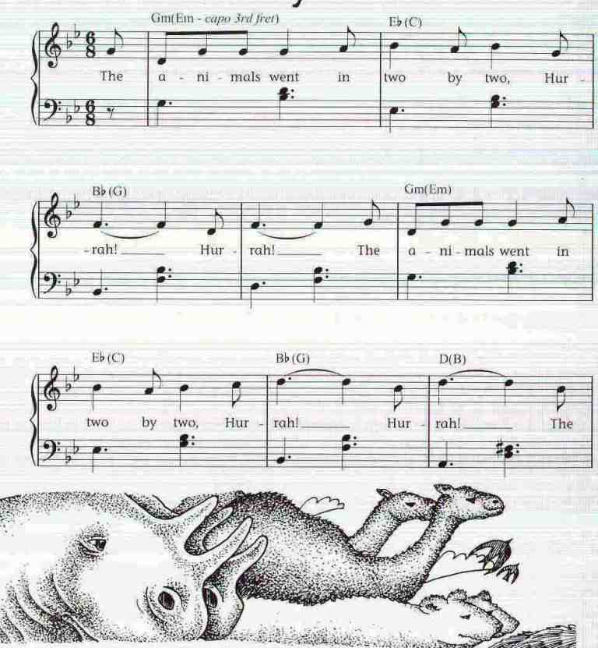
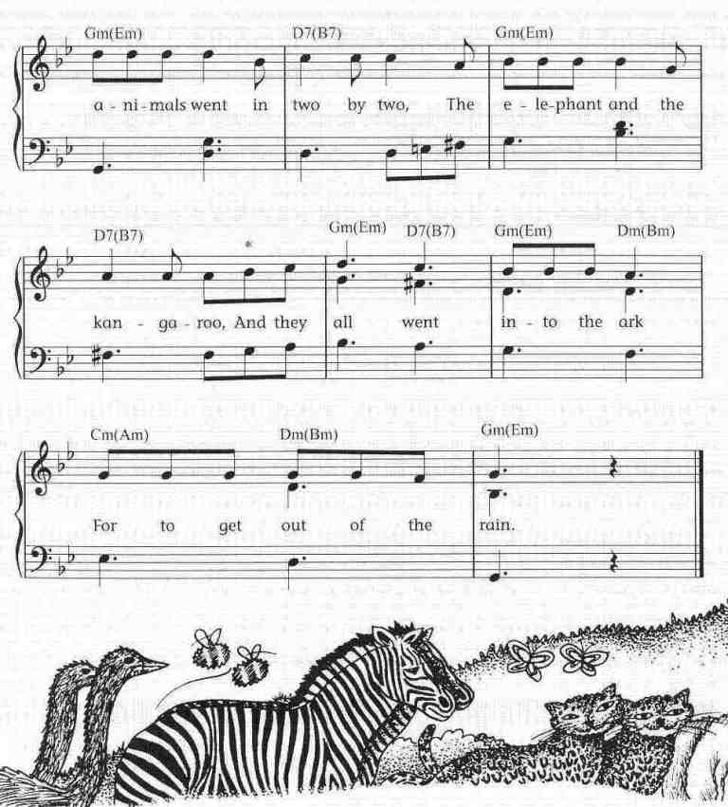
The animals went in two by two, hurrah! hurrah!
The animals went in two by two, the elephant and the kangaroo
And they all went into the ark, for to get out of the rain.

The animals went in three by three, hurrah! hurrah!
The animals went in three by three, the wasp, the ant and the bumble bee …

The animals went in four by four, hurrah! hurrah!
The animals went in four by four, the great hippopotamus stuck in the door …

The animals went in five by five, hurrah! hurrah!
The animals went in five by five, they warmed each other to keep alive …

The animals went in six by six, hurrah! hurrah!
The animals went in six by six, they turned out the monkey because of his tricks …

The animals went in seven by seven, hurrah! hurrah!
The animals went in seven by seven, the little pig thought he was going to heaven …

Variant:
The ants go marching one by one hurrah…
the little one stopped and sucked his thumb
two by two … tie his shoe
three … climb a tree
four… knock on a door
five … learn how to drive
six … pick up sticks
seven … went to heaven
eight … shut the gate
nine … walk on a line
ten … to shout THE END

The Train’s A-coming, oh yeah(oh yes)
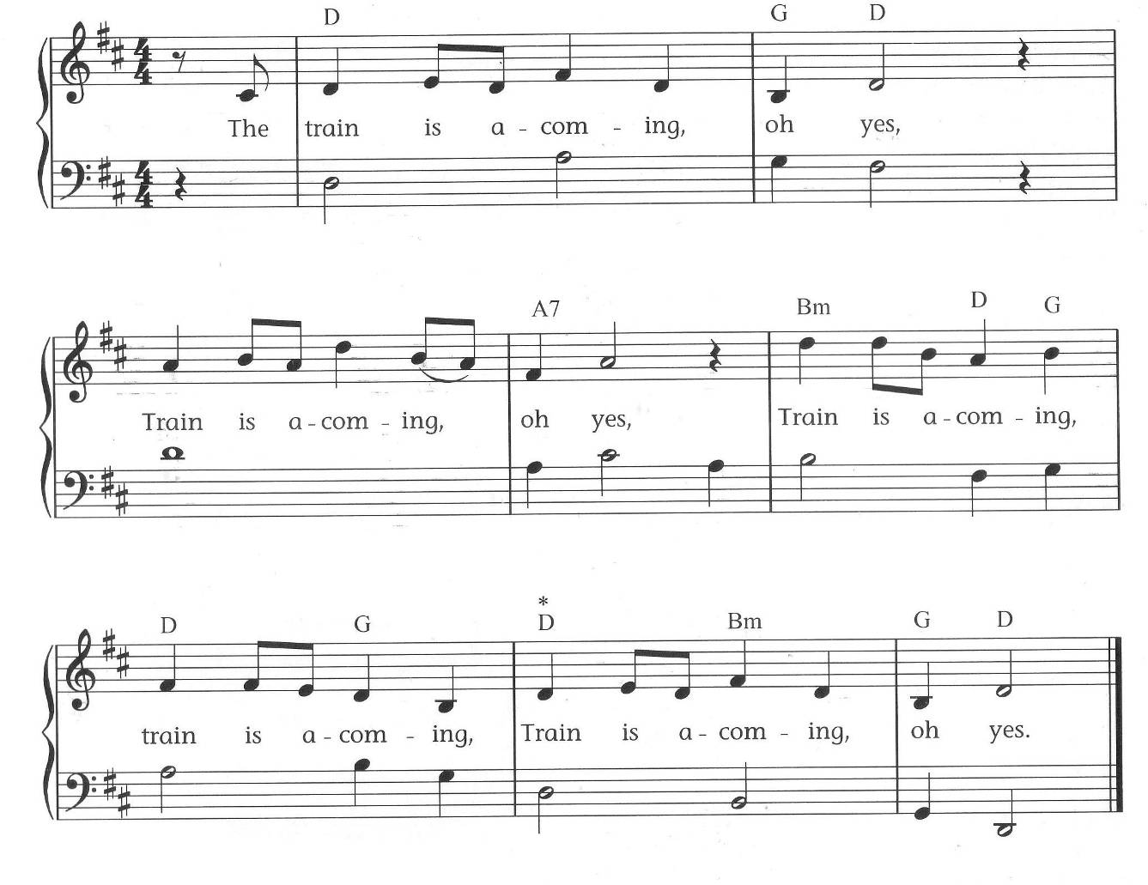
The train is a-coming, oh yeah, …

You better get your ticket

The train is a-leaving

We’re going to the seaside / mountains / city / heaven, etc

It’s time to go home now

This song originally had a very different meaning, which becomes clear when we listen to the gospel type melody. It could be rewritten by the children in a variety of ways…

http://www.gardenofsong.com/sunflower.html

There was an old man called Michael Finnegan
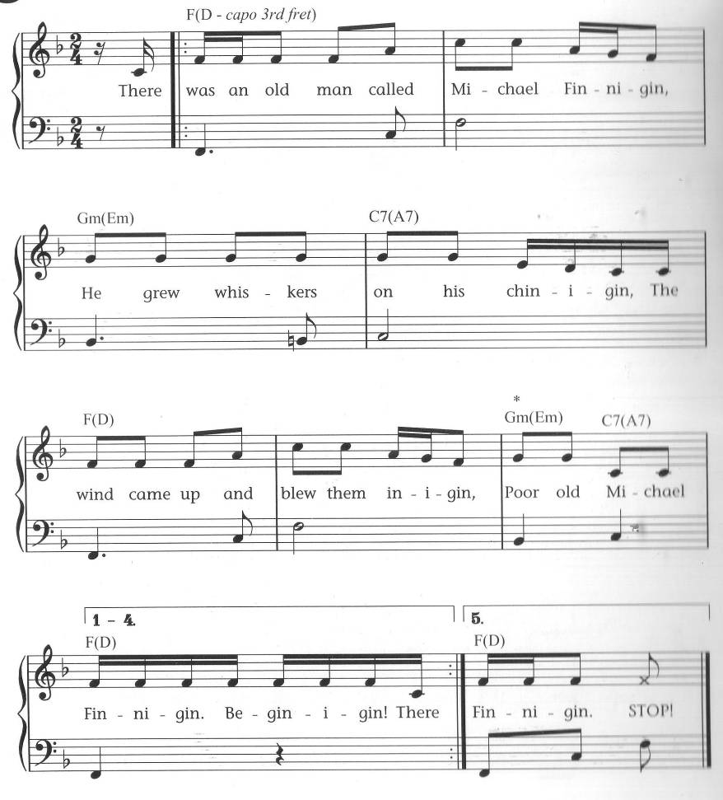

There was an old man named Michael Finnegan
He had whiskers on his chin again
Along came the wind and blew them in again
Poor old Michael Finnegan....Begin again.

There was an old man named Michael Finnegan
He kicked up an awful din again
Because they said he must not sing again
Poor old Michael Finnegan....Begin again.

There was an old man called Michael Finnegan
Ran a race and thought he’d win again
Got so puffed that he had to go in again
Poor old Michael Finnegan....Begin again.

There was an old man named Michael Finnegan
He drank through all his good gin again
And so he wasted all his tin (=money) again
Poor old Michael Finnegan....Begin again.

There was an old man named Michael Finnegan
He went fishing with a pin again
Caught a fish and dropped it in again
Poor old Michael Finnegan....Begin again.

There was an old man called Michael Finnegan
Climbed a tree and scraped his shin again
Took off several yards of skin again
Poor old Michael Finnegan....Begin again.

There was an old man named Michael Finnegan
He grew fat and then grew thin again
Then he died and had to begin again
Poor old Michael Finnegan....Begin again.

http://www.mamalisa.com/midi/michael_finnegan.mid

Heads Shoulders Knees and Toes
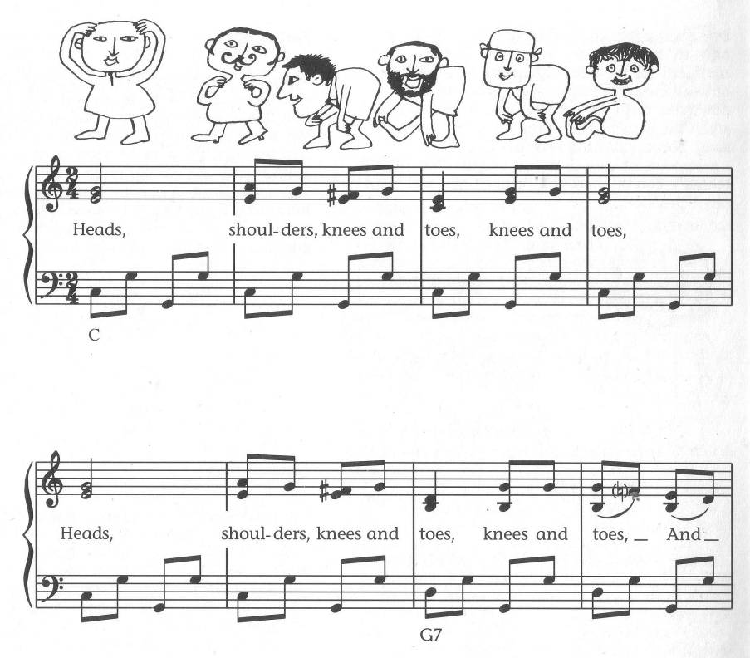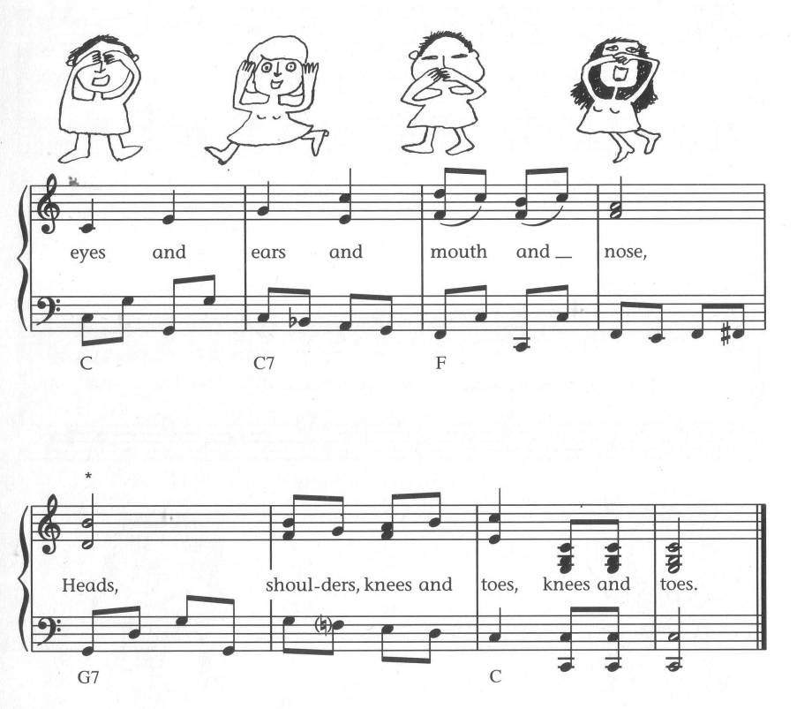

http://www.youtube.com/watch?v=gFuZ6LPDYQc

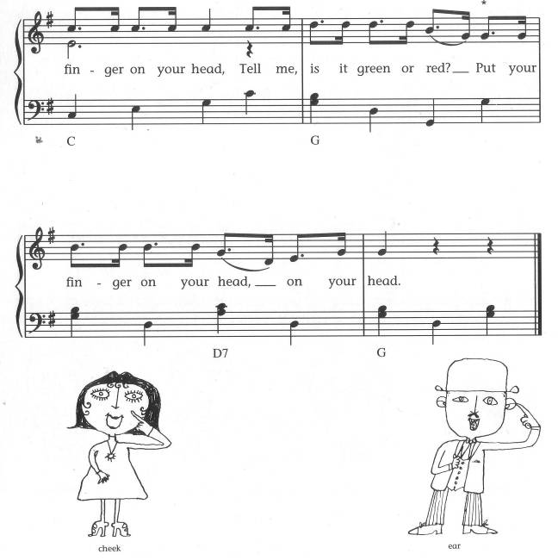
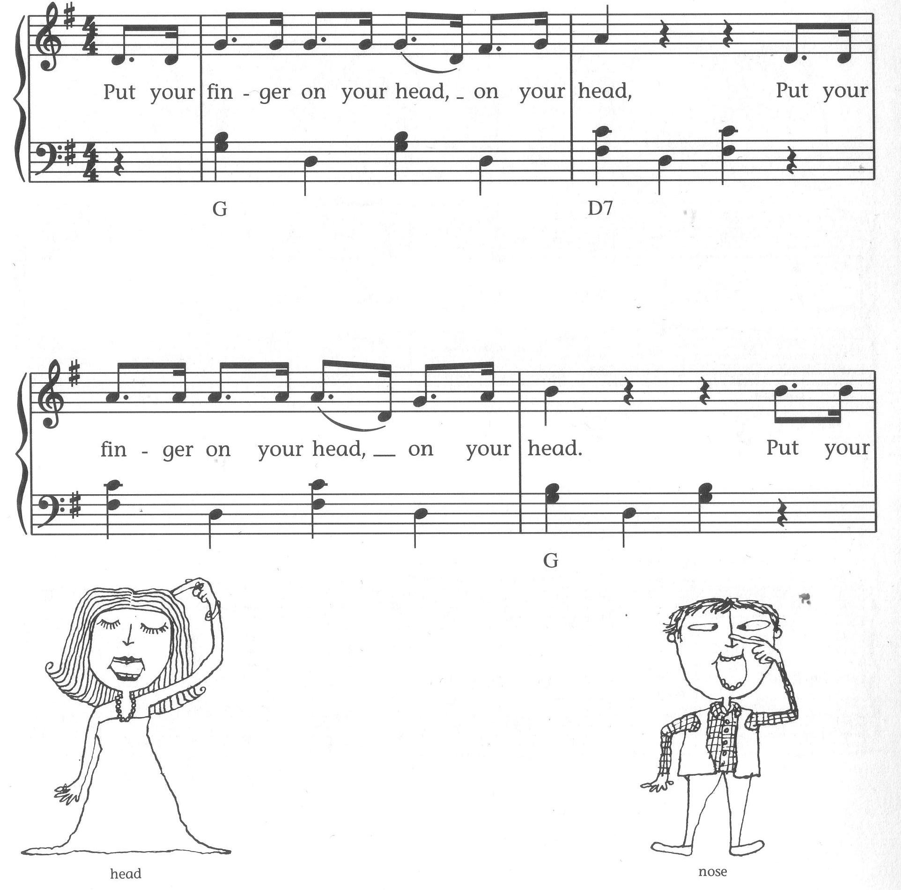
Finger on your head

Put your finger on your head on your head (2x)
Put your finger on your head and point to something red
Put your finger on your head on your head

Put your finger on your nose on your nose (2x)
Put your finger on your nose and your elbow on your toes …
Put your finger on your nose on your nose

Put your finger on your back …
… and point to something black

Put your finger on your knees …
… and make a great big sneeze

Put your finger where you think …
… and point to something pink

Put your finger to a fellow …
… and point to something yellow

Put your finger on your shoe …
… and point to something blue

Put your finger up and down …
… and point to something brown

Put your finger in your ear …
… and leave it there for a year

words and music: Woody Guthrie
http://www.sillybooks.net/books/FingerInAir/PutYourFingerInTheAir.html

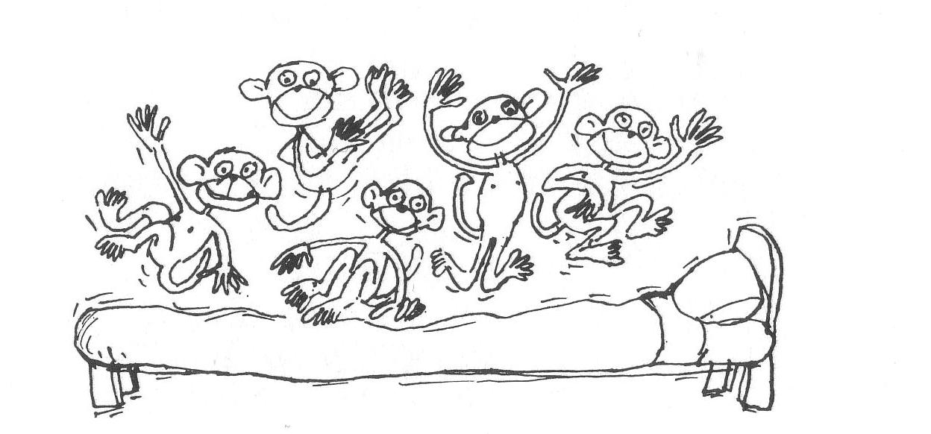
Five Little Monkeys

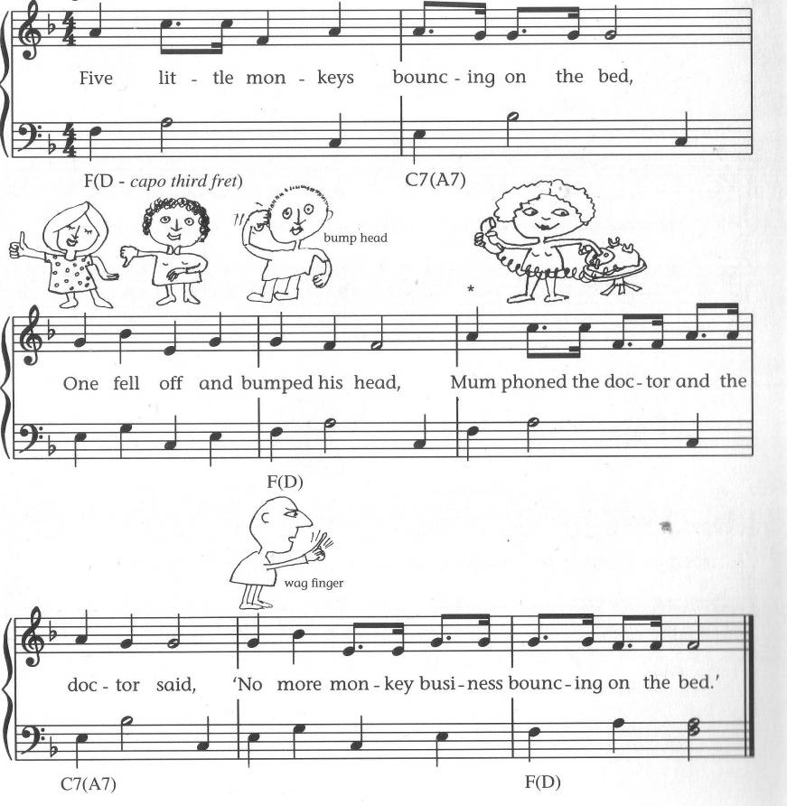

Five little monkeys bouncing on the bed,
One fell off and bumped his head.
Mama called the Doctor and the Doctor said,
„No more monkeys bouncing on the bed!”

Four little monkeys bouncing on the bed,
…

Three little monkeys bouncing on the bed,
…

Two little monkeys bouncing on the bed,
…

One little monkey bouncing on the bed,
He fell off and bumped his head.
Mama called the Doctor and the Doctor said,
„Put those monkeys straight to bed!”

Cousin Peter
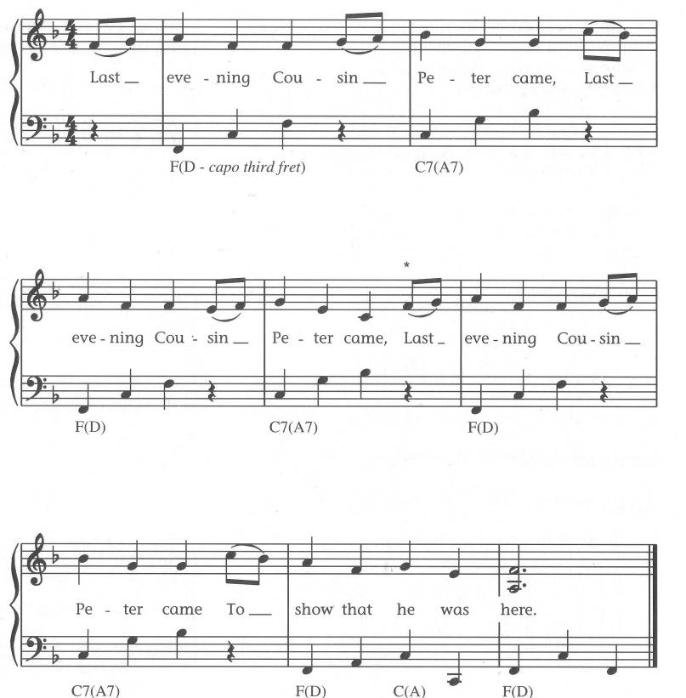

- Last evening cousin Peter came,
Last evening cousin Peter came,
Last evening cousin Peter came,
To say that he was here.

- He knocked three times upon the door,

- He wiped his feet upon the mat,

- He hung his hat upon a hook,

- He took his coat off arm by arm,

- He kicked his boots off one by one.

- He danced around in his stocking feet.

- He stomped around like a grizzly bear.

- He twirled around on his tippy toes.

I Jump Out of Bed in the Morning
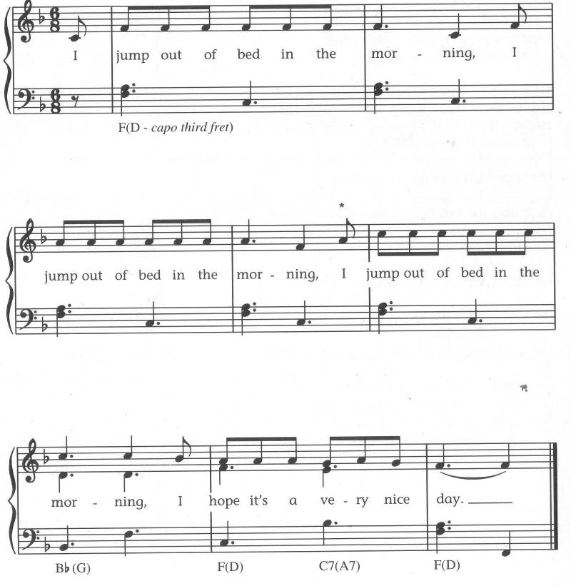

I jump out of bed in the morning (3x)
I hope it’s a very nice day.

I jump out of bed and stretch myself in the morning (3x)
I hope it’s a very nice day.

I jump out of bed and stretch myself and step in the bath in the morning (3x) …

… wash myself …
… dress myself …
… brush my teeth …
… comb my hair …
… eat my toast …
… wave goodbye …
… walk/run/cycle etc to school …

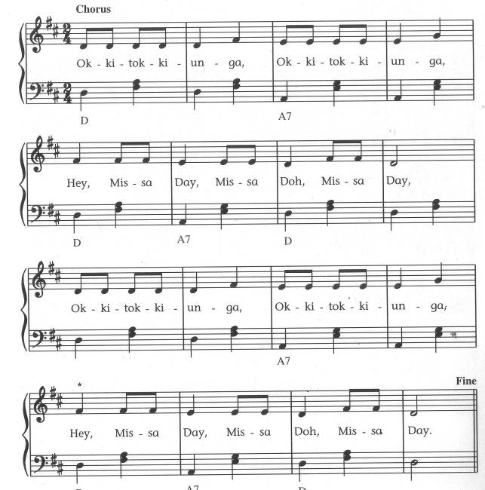
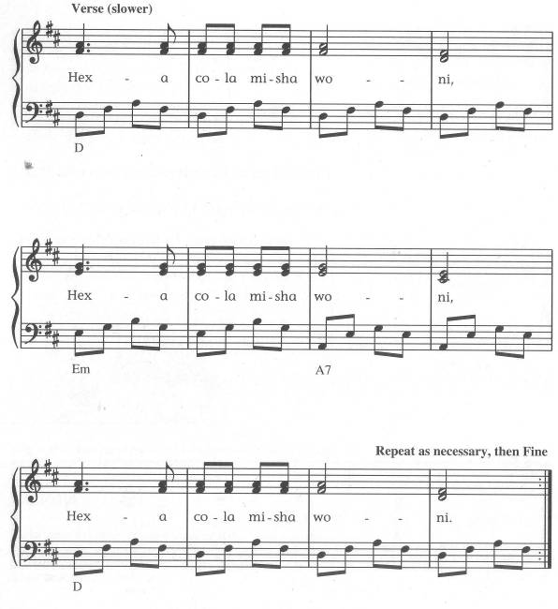
Okki-Tokki-Unga

This is more of a story-telling exercise

http://www.youtube.com/watch?v=wmp8fsgLmpM (child singing it with the actions)
http://www.youtube.com/watch?v=2QetXHEQ7kw&feature=related (commercial recording, no actions)

For the story and a similar song see http://www.morrissey.unibe.ch/swch/swch07/Karin%27s_story.pdf

Who Built the Ark? Noah, Noah!
Now didn’t old Noah build the ark?
Built it out of hickory bark.
He built it long, both wide and tall,
Plenty of room for the large and small.
He found him an axe and hammer too,
Began to cut and began to hew.
And every time that hammer rang,
Noah shouted and Noah sang.

Who built the Ark? Noah, Noah!
Who built the Ark? Brother Noah built the Ark.

Now in came the animals two by two,
Hippopotamus and kangaroo.
Now in came the animals 3 by 3,
Two big cats and a bumble bee.
Now in came the animals 4 by 4,
Two through the window and two through the door.
Now in came the animals 5 by 5,
Four little sparrows and the redbird’s wife.

Who built the Ark? Noah, Noah!
Who built the Ark? Brother Noah built the Ark.

Now in came the animals 6 by 6,
Elephant laughed at the monkey’s tricks.
Now in came the animals 7 by 7,
Four from home and the rest from heaven.
Now in came the animals 8 by 8,
Some were on time but the others were late.
Now in came the animals 9 by 9,
Some were shouting and some were crying.

Who built the Ark? Noah, Noah!
Who built the Ark? Brother Noah built the Ark.

Now in came the animals10 by 10,
Five black roosters and five black hens.

Now Noah says, „Go shut that door.
The rain’s started dropping and we can’t take more.”

http://www.morrissey.unibe.ch/swch/
A Music Hall version with good pictures: http://youtube.com/watch?v=jJQeYFjt2Mc&feature=related

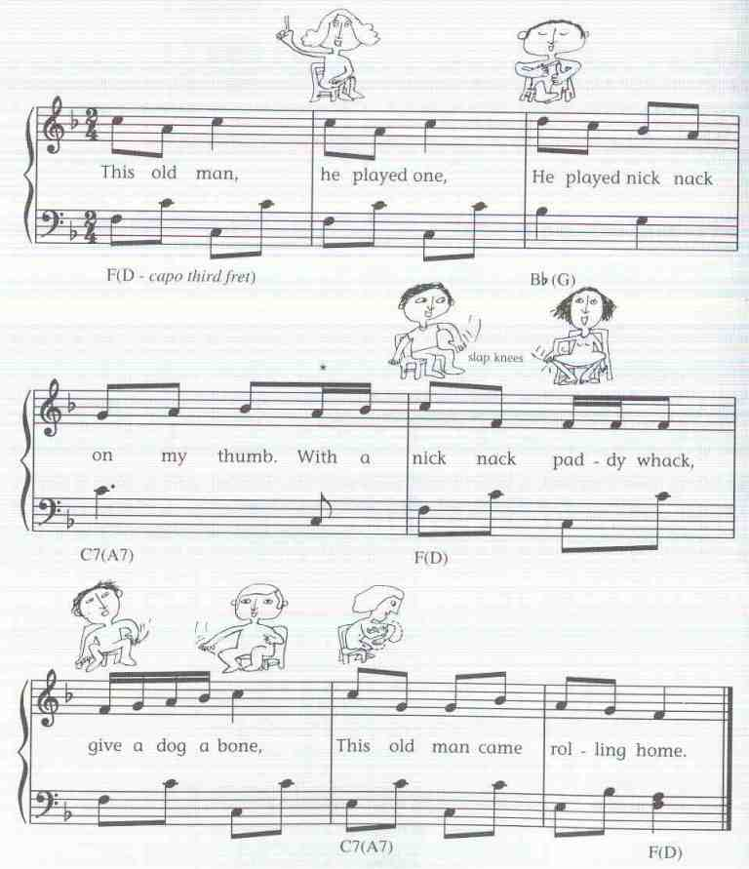
This Old Man
This old man, he played one, (1)
He played knick knack on my thumb,
With a knick, knack, paddy whack,
Give the dog a bone;
This old man came rolling home.

This old man, he played two, (2)
He played knick knack on my shoe,
With a knick, knack, …

This old man, he played three, (3)
He played knick knack on my knee,
With a knick, knack, …

This old man, he played four, (4)
He played knick knack on door,
With a knick, knack, …

This old man, he played five, (5)
He played knick knack on my hive,
With a knick, knack, …

This old man, he played six, (6)
He played knick knack on my sticks,
With a knick, knack, …

This old man, he played seven, (7)
He played knick knack up in heaven,
With a knick, knack, …

This old man, he played eight, (8)
He played knick knack on my gate,
With a knick, knack, …

This old man, he played nine, (9)
He played knick knack, rise and shine,
With a knick, knack, …

This old man, he played ten, (10)
He played knick knack on my hen,
With a knick, knack, …

http://www.enchantedlearning.com/rhymes/Thisoldman.shtml
http://youtube.com/watch?v=8zhWOcLM1ss

My Brother Sylvest
Chorus: He was my brother Sylvest (What’s he got?)
A row of forty medals on his chest (Big Chest!)
he killed fifty badmen in the west
he knew no rest, thinking a man’s hell fire,
don’t push, just shove, plenty of room for you and me.
He’s got an arm (Got an Arm!)
like a leg (Like a leg!)
and a punch that can sick a battle ship, (Big Ship!)
it takes all the army and the navy
to put the wind up Sylvest

Well, he’d thought he’d take a trip to Italy,
he thought he’d take a trip by sea,
he jumped in the harbour in New York,
swam like a man made of cork.
He saw the Lusitania in distress, (What’d he do?)
He put the Lusitania on his chest, (Big Chest!)
drank up all the water in the sea
and walked all the way to Italy.

Well, he thought he’d take a trip to old Japan,
they brought out the big brass band,
he played every instrument they had, (What a lad!)
he played the whole lot,
well the church bells all will ring (Ding Dong)
and the church choirs all will sing (La la la!)
they’ll all come out to bid farewell
to my big brother Sylvest.

(for another version and one verse http://www.irishsongs.com/lyrics.php?Action=view&Song_id=40)
http://youtube.com/watch?v=Tji3IakVGK4 (useful pictures to go with the lyrics and additional verse)

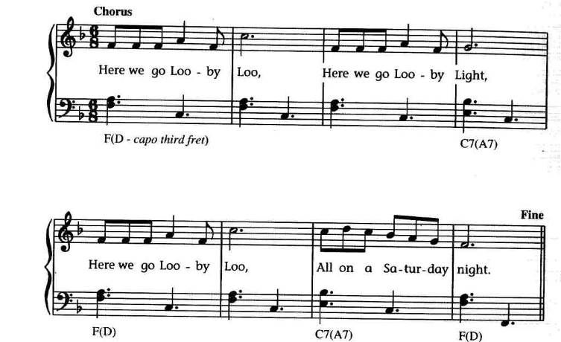
Looby Loo
Chorus Here we go looby loo, here we go looby light
Here we go looby loo, all on a Saturday night
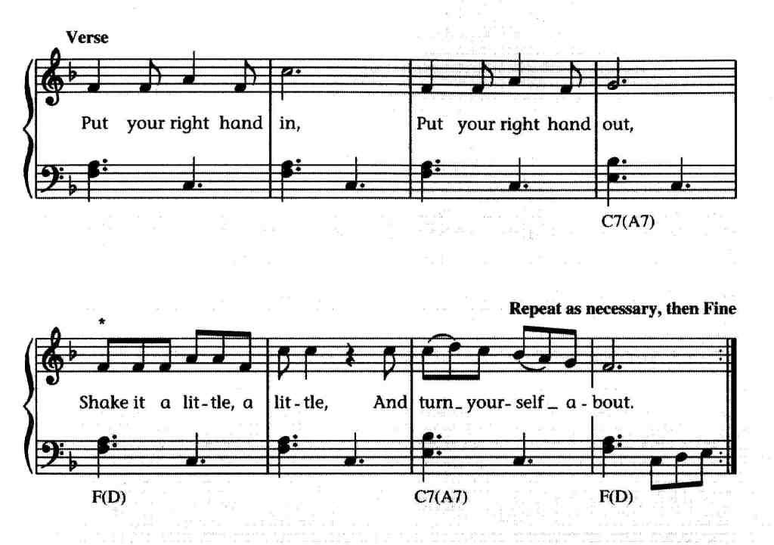

You put your right hand in
You take your right hand out
Shake it a little, a little
And turn yourself about

You put your left hand in

You put your right foot in

You put your left foot in

…

You put your whole self in
You take your whole self out
Shake yourself a little, a little
And turn yourself about

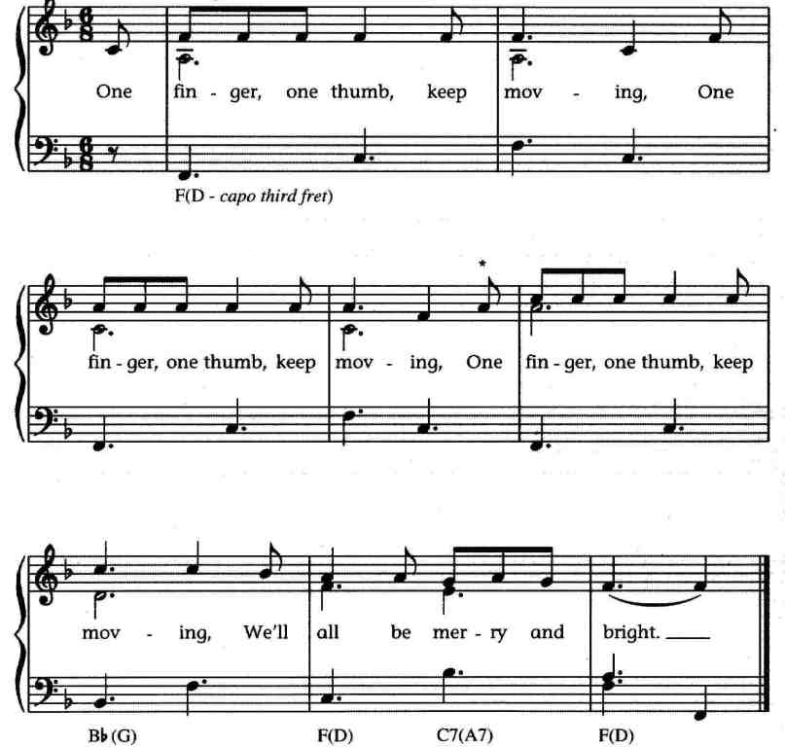
One Finger One Thumb

One finger, one thumb, keep moving
One finger, one thumb, keep moving
One finger, one thumb, keep moving
We’ll all be merry and bright

One finger, one thumb, one arm, keep moving
…
We’ll all be merry and bright

One finger, one thumb, one arm, one leg, keep moving
…
We’ll all be merry and bright

One finger, one thumb, one arm, one leg, one nod of the head, keep moving
…
We’ll all be merry and bright

One finger, one thumb, one arm, one leg, one nod of the head, sit down, stand up, keep moving
…
We’ll all be merry and bright

slightly childish presentation of the song
http://www.bbc.co.uk/cbeebies/tweenies/songtime/songs/o/onefinger.shtml

Alison’s Camel
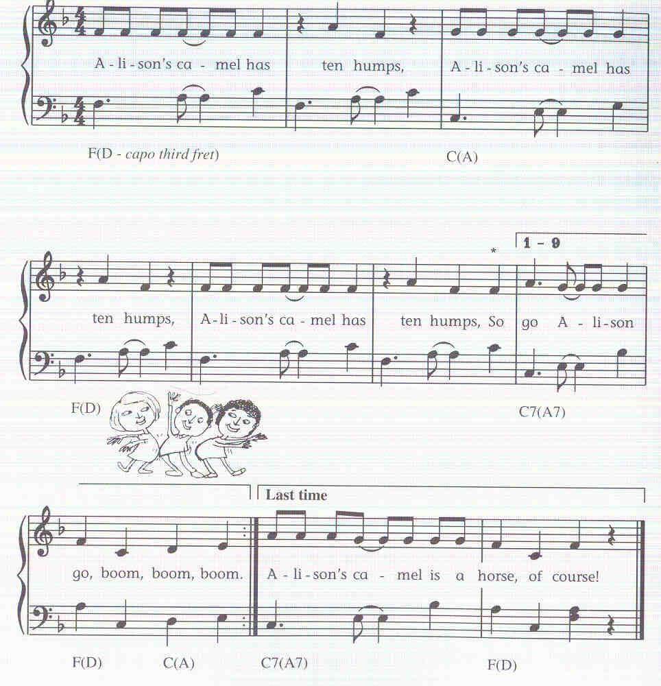
Alison’s camel has -- ten humps,
Alison’s camel has -- ten humps,
Alison’s camel has -- ten humps,
So go Alison, go! Boom, boom, boom

Alison’s camel has nine humps...

Alison’s camel has eight humps...

Alison’s camel has no humps,
Alison’s camel has no humps,
Alison’s camel has no humps
So Alison has a horse, of course!

The Wheels on the Bus
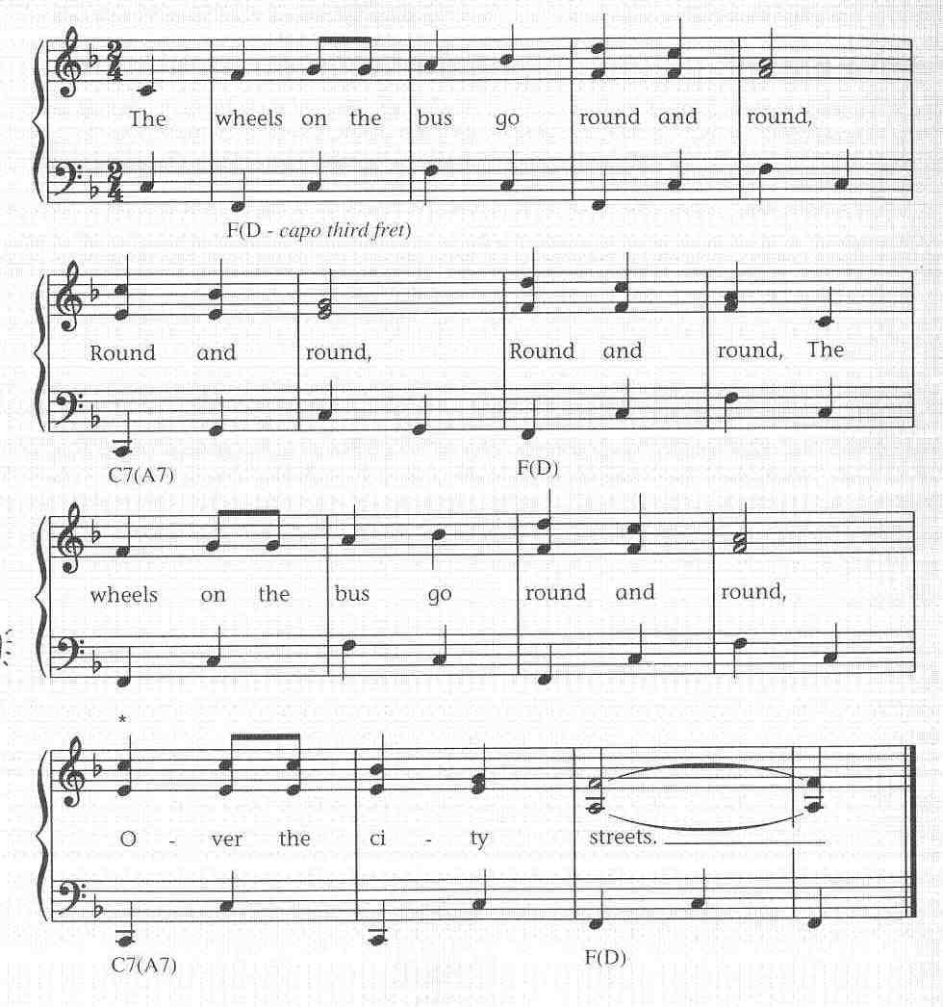
The wheels on the bus go round and round,
round and round, round and round.
The wheels on the bus go round and round,
over the city streets.

The wipers on the bus go swish, swish, swish;

The horn on the bus …
More suggestions:

The driver on the bus says „Move on back,
The baby on the bus says „Wah, wah, wah;
The mommy on the bus says „Shush, shush, shush;
The doors on the bus go open and shut.
The bell on the bus goes ding-ding-ding.
The lady on the bus says, „Get off my feet“...
The people on the bus say, „We had a nice ride“...
„Your name“ on the bus says Let Me Off!

The old ladies on the bus …
…

http://kids.niehs.nih.gov/lyrics/wheels.htm

Miss Polly
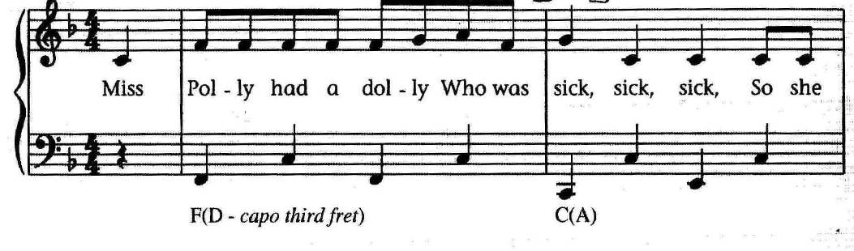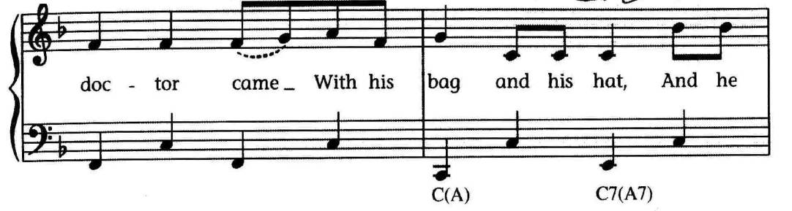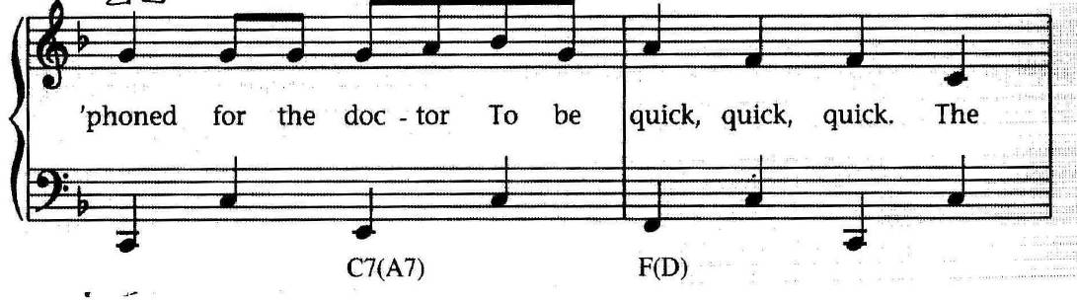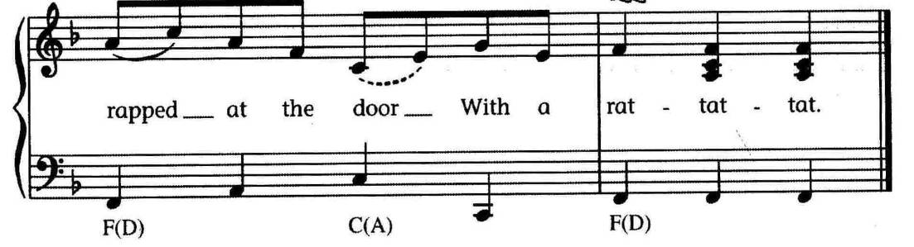

Miss Polly had a dolly
Who was sick, sick, sick,
So she called for the doctor
To be quick, quick, quick;
The doctor came
With his bag and his hat,
And he knocked at the door
With a rat-a-tat-tat.

He looked at the dolly
And he shook his head,
And he said „Miss Polly,
Put her straight to bed.“
He wrote out a paper
For a pill, pill, pill,
„I’ll be back in the morning
With the bill, bill, bill.“

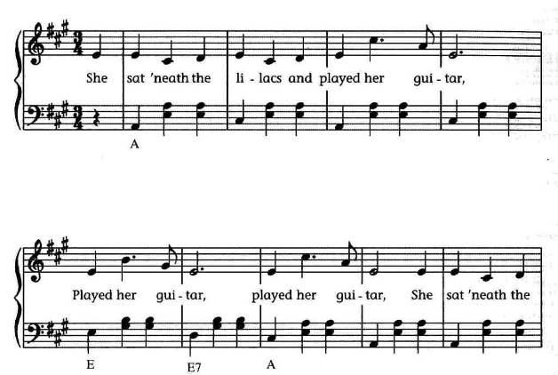
Under the Lilacs
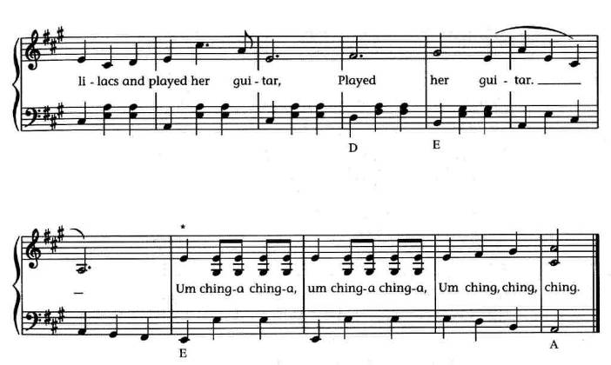

She sat under the lilacs and played her guitar,
played her guitar, played her guitar.
She sat under the lilacs and played her guitar,
played her guitar.
Chorus: Um ching-a ching-a, um ching-a ching-a,
Um ching, ching, ching.

He sat down beside her and smoked his cigar.

He said that he loved her but oh, how he lied.

She said she believed him but oh, how she sighed.

They were to be married but she up and died.

He went to her funeral but just for the ride.

He sat on her tombstone and laughed till he cried.

The tombstone fell on him and squish-squash he died

She went to heaven and flip-flip she flied.

He went the other way and frizzled and fried.

The moral of this story is: don’t tell a lie.

After the Ball

original:

After the ball is over
After the break of dawn
After the dancers’ leaving
After the stars are gone
Many a heart is aching
If you could read them all
Many the hopes that have vanished
After the ball
parody: After the Ball (Dismantled Bride)

After the ball was over
She took out her glass eye.
Kicker her cork leg in the corner,
Corked up her bottle of dye.
Put her false teeth in the water;
stripped off her false nails and all.
The what was left went to the bye-byes, (beddie-byes)
After the ball.

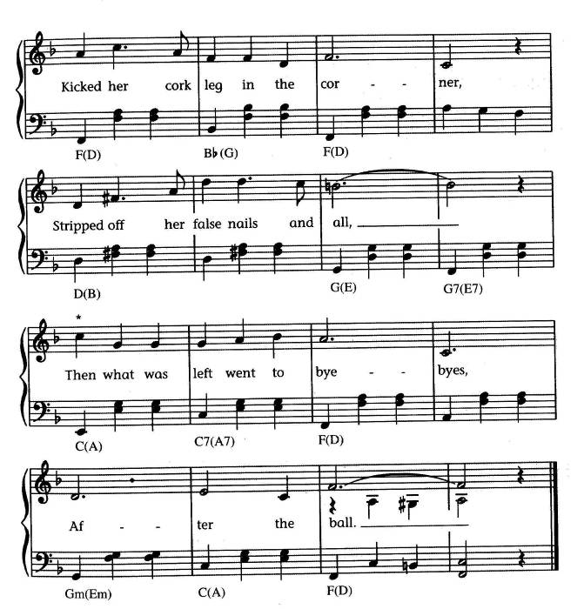
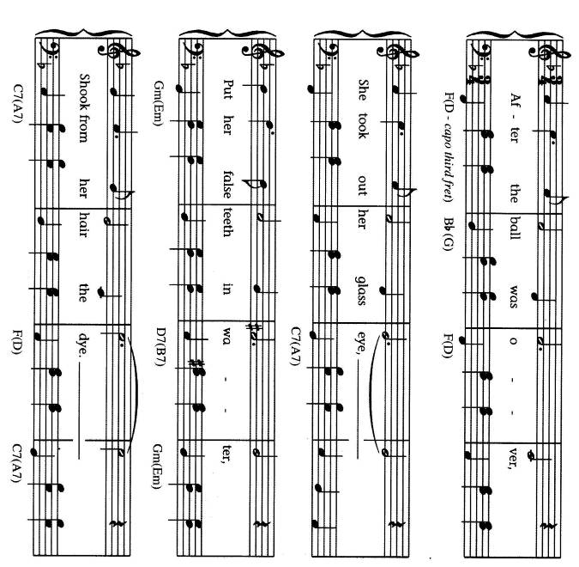

tune and original lyrics
http://www.kinglaoghaire.com/site/lyrics/song_183.html

John Brown’s Baby
John Brown’s baby has a cold upon his chest,
John Brown’s baby has a cold upon his chest,
John Brown’s baby has a cold upon his chest,
So they rubbed it with camphorated oil.

Camphor-amphor-amphor-ated
Camphor-amphor-amphor-ated
Camphor-amphor-amphor-ated
So they rubbed it with camphorated oil.

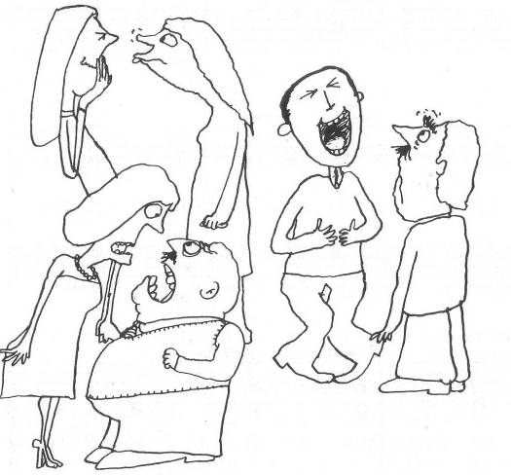
The No-Laugh Race

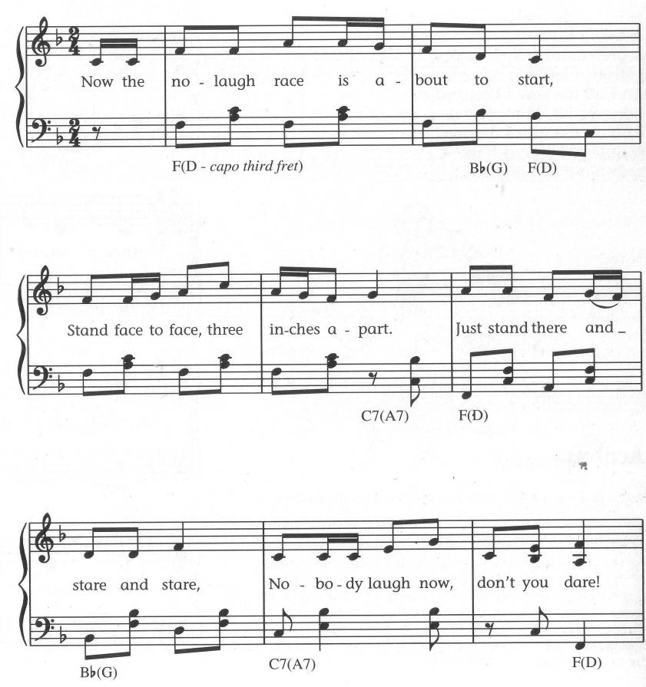
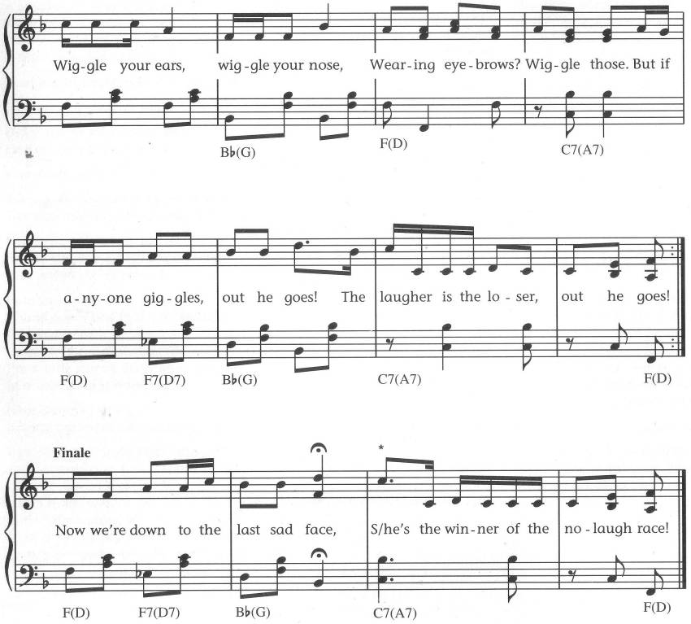

Do Your Ears Hang Low
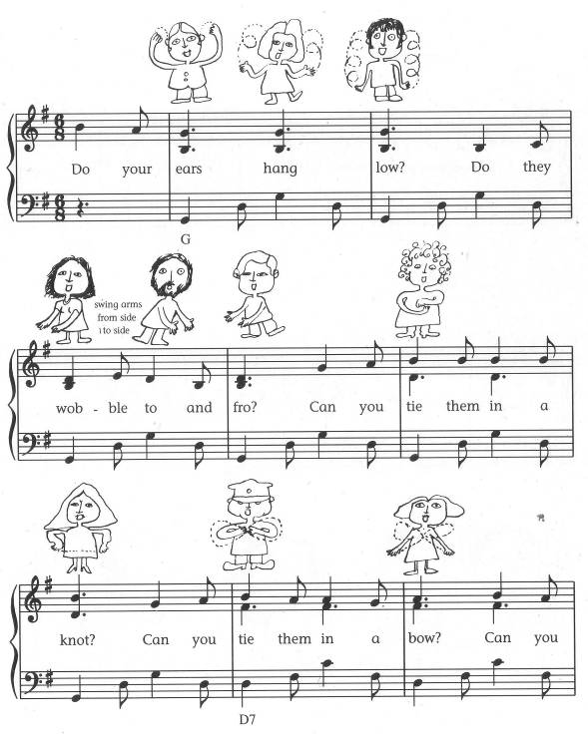
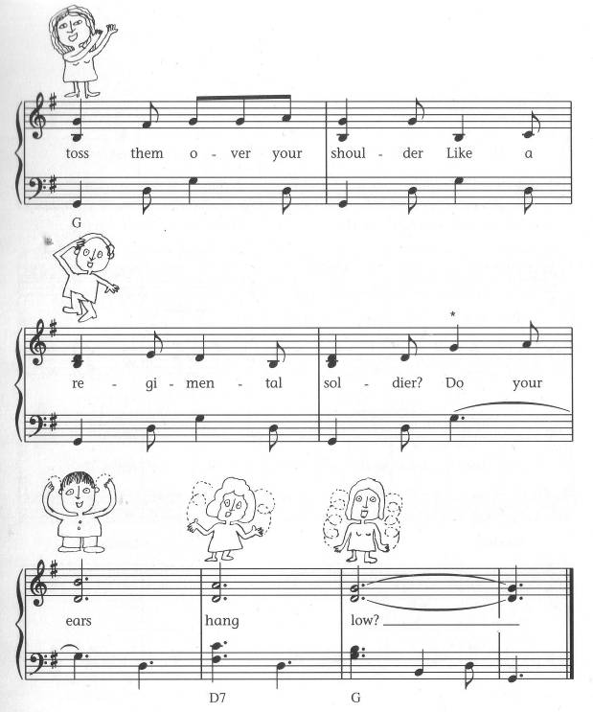

Do your ears hang low?
Do they wobble to and fro?
Can you tie them in a knot?
Can you tie them in a bow?
Can you throw them o’er your shoulder
Like a regimental soldier?
Do your ears hang low?
Do your ears hang high?
Do they reach up to the sky?
Do they wrinkle when they’re wet?
Do they straighten when they’re dry?
Can you wave them at your neighbour
With an element of flavour?
Do your ears hang high?
Do your ears hang wide?
Do they flap from side to side?
Do they wave in the breeze
From the slightest little sneeze?
Can you soar above the nation
With a feeling of elation?
Do your ears hang wide?
Do your ears fall off
When you give a great big cough?
Do they lie there on the ground
Or bounce up at every sound?
Can you stick them in your pocket
Just like Davy Crocket?
Do your ears fall off?
Does your tongue hang down?
Does it flop all around?
Can you tie it in a knot?
Can you tie it in a bow?
Can you throw it o’er your shoulder
Like a regimental soldier?
Does your tongue hang down?
Does your nose hang low?
Does it wiggle to and fro?
Can you tie it in a knot?
Can you tie it in a bow?
Can you throw it o’er your shoulder
Like a regimental soldier?
Does your nose hang low?
Do your eyes pop out?
Do they bounce all about?
Can you tie them in a knot?
Can you tie them in a bow?
Can you throw them o’er your shoulder
Like a Continental Soldier?
Do your eyes pop out?

http://www.kididdles.com/lyrics/d006.html

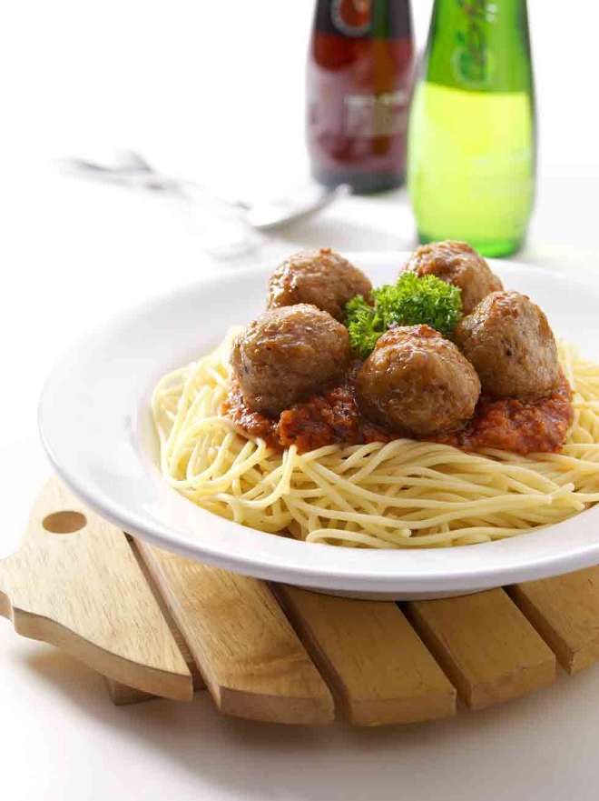
On Top of Spaghetti
On top of spaghetti all covered with cheese
I lost my poor meatball when somebody sneezed

It rolled off the table, it rolled on the floor
And then my poor meatball rolled out of the door

It rolled in the garden and under a bush
And then my poor meatball was nothing but mush.

The mush was as tasty as tasty could be,
And early next summer it grew to a tree.

The tree was all covered with beautiful moss
It grew great big meatballs and tomato sauce.

So if you eat spaghetti all covered with cheese,
Hold on to your meatball and don’t ever sneeze.

http://youtube.com/watch?v=uQEp8wKqyLk (good song version, rubbish animation)

On Top of Old Smokey
On top of Old Smokey, all covered with snow,
I lost my true lover, for courting too slow.

For courting’s a pleasure, but parting is grief,
And a false-hearted lover, is worse than a thief.

A thief will just rob you, and take what you have,
But a false-hearted lover, will lead you to your grave.

The grave will decay you, and turn you to dust,
Not one boy in a hundred a poor girl can trust.

They’ll hug you and kiss you, and tell you more lies,
Than crossties on a railroad, or stars in the sky.

So come ye young maidens, and listen to me,
Never place your affection in a green willow tree.

For the leaves they will wither, the roots they will die,
And you’ll be forsaken, and never know why.

Jim Along Josie

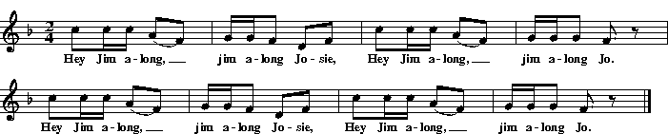

Hey Jim along, jim along Josie,
Hey Jim along, jim along Jo.
Hey Jim along, jim along Josie,
Hey Jim along, jim along Jo.
Walk Jim along, jim along Josie,
Walk Jim along, jim along Jo.
Walk Jim along, jim along Josie,
Walk Jim along, jim along Jo.
Hop Jim along
Run Jim along
Jump Jim along
Tiptoe Jim along
Crawl Jim along
Swing Jim along
http://www.folkinfo.org/songs/displaysong.php?songid=546
http://www.morrissey.unibe.ch/swch/

Someone’s in the Kitchen with Dinah
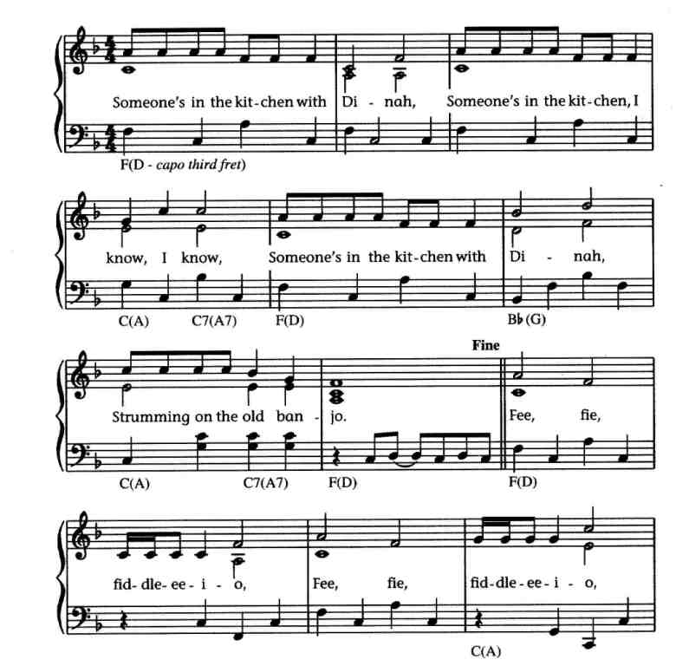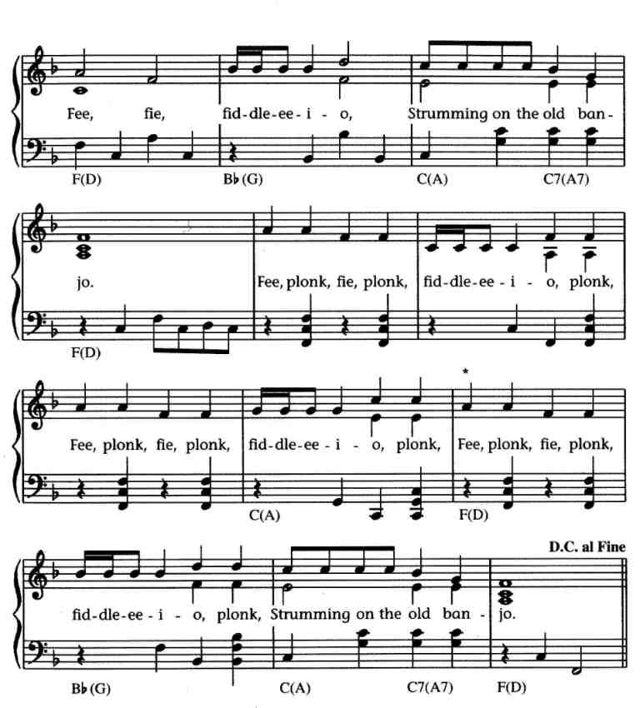

Someone’s in the kitchen with Dinah,
Someone’s in the kitchen I know, I know,
Someone’s in the kitchen with Dinah,
Playing/strumming on the old banjo.

Singing fee, fie, fiddlee-i-o
Fee, fie, fiddlee-i-o
Fee, fie, fiddlee-i-o
Strumming on the old banjo.

Singing fee, plonk, fie, plonk, fiddlee-i-o, plonk,
Fee, plonk, fie, plonk, fiddlee-i-o, plonk,
Fee, plonk, fie, plonk, fiddlee-i-o, plonk,
Strumming on the old banjo.

Instruments
fee flute
fie clarinette
fiddle-i-o violin
plonk drum
strum banjo

Frog Went a-Courting
Frog went a-courting and he did ride, Uh-huh, (3x)
With a sword and a pistol by his side, Uh-huh.

Well he rode up to Miss Mouse’s door, Uh-huh,
Gave three loud raps and a very big roar, Uh-huh.

Said he, „Miss Mouse, are you within?” Uh-huh,
„Yes, kind sir, I sit and spin,” Uh-huh.

He took Miss Mouse upon his knee, Uh-huh,
Said, „Miss Mouse, will you marry me?” Uh-huh.

„Without my uncle Rat’s consent, Uh-huh
I wouldn’t marry the president, Uh-huh.

Uncle Rat laughed and he shook his fat sides, Uh-huh,
To think his niece would be a bride, Uh-huh.

Uncle Rat went running downtown, Uh-huh,
To buy his niece a wedding gown, Uh-huh

Where shall the wedding supper be? Uh-huh,
Way down there in that hollow tree, Uh-huh

What should the wedding supper be? Uh-huh,
Fried mosquito in a black-eye pea, Uh-huh.

Well, first to come in was a flying moth, Uh-huh,
She laid out the table cloth, Uh-huh.

Next to come in was a juney bug, Uh-huh,
She brought the water jug, Uh-huh.

Next to come in was a bumbley bee, Uh-huh
Sat mosquito on his knee, Uh-huh.

Next to come in was a broken black flea, Uh-huh,
Danced a jig with the bumbley bee, Uh-huh.

Next to come in was Mrs. Cow, Uh-huh,
She tried to dance but she didn’t know how, Uh-huh.

Next to come in was a little black tick, Uh-huh,
She ate so much she made us sick, Uh-huh.

Next to come in was a big black snake, Uh-huh,
Ate up all of the wedding cake, Uh-huh.

Next to come was the old gray cat, Uh-huh,
Swallowed the mouse and ate up the rat, Uh-huh.w

Mr. Frog went hopping up over the brook, Uh-huh,
And a big black snake swallowed him up, Uh-huh.

A little piece of cornbread is lying on a shelf, Uh-huh,
If you want to hear some more, you can sing it yourself, Uh-huh.

http://youtube.com/watch?v=eTNrSL-r1ms&feature=related
Bob Dylan singing with a stupid animation

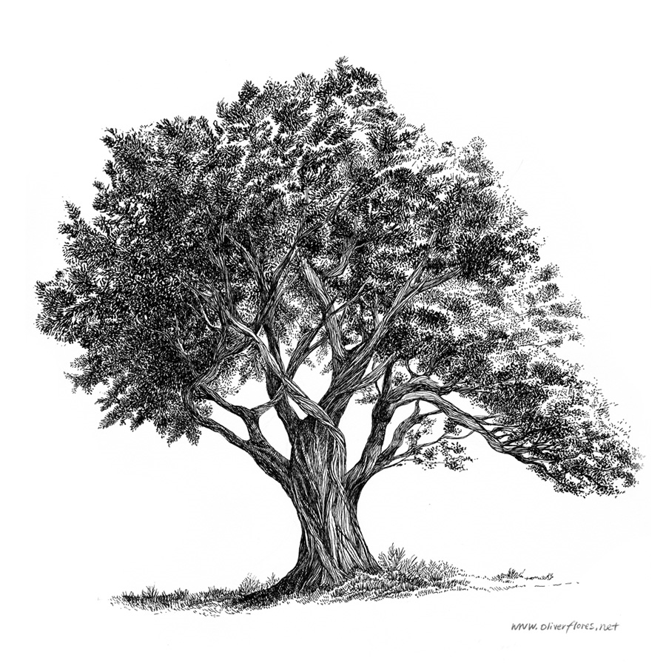
The Rattling Bog
Hey ho, a rattling bog,
The bog down in the valley-o.
A rare bog, a rattling bog,
A bog down in the valley-o.

Now in that bog there was a tree,
A rare tree, a rattling tree,
And the tree in the bog,
And the bog down in the valley-o.

Hey ho, a rattling bog,
A bog down in the valley-o. (2x)

Now on that tree there was a branch,
A rare branch, a rattling branch,
And the branch on the tree,
And the tree in the bog,
And a bog down in the valley-o.

Now on that branch there was a twig,
A rare twig, a rattling twig, …

Now on that twig there was a nest, …

Now in that nest there was a bird, …

Now on that bird there was a feather, …

Now on that feather there was a bug, …
http://www.youtube.com/watch?v=vWw88m8dsTY

Herrings’ Heads

Oh, what shall we do with the herring’s heads?
We’ll make them into loaves of bread,
We’ll make them into loaves of bread,
Sing fala matoora tay.
Herring’s heads, loaves of bread,
And all sort of things.

Chorus: The herring is the king of the sea,
The herring is the fish for me,
The herring is the king of the sea,
Sing fala matoora tay.

Oh, what shall we do with the herring’s eyes?
We’ll make them into puddings and pies, (2x)
Sing fala matoora tay.
Herring’s eyes, puddings and pies,
Herring’s heads, loaves of bread,
And all sorts of things.

Oh, what will we do with the herring’s fins?
We’ll make them into needles and pins,
…

Oh, what will we do with the herring’s back?
We’ll make it a laddie, and call him Jack,
…

Oh, what will we do with the herring’s belly?
We’ll make it a lassie and call her Nellie,
…

Oh, what will we do with the herring’s tail?
We’ll make it a ship with a beautiful sail, (2x)
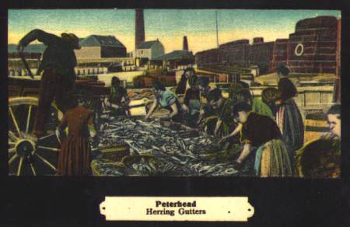
Sing fala matoora tay.
Herring’s tails, ships and sails,
Herring’s bellies, lassies and Nellies,
Herring’s backs, laddies and Jacks,
Herring’s fins, needles and pins,
Herring’s eyes, puddings and pies,
Herring’s heads, loaves of bread,
And all sort of things.

Pick a Bale of Cotton
I’m gonna jump down, turn around,
Pick a bale of cotton
Gonna jump down, turn around,
Pick a bale a day
Oh lordy, pick a bale of cotton
Oh lordy, pick a bale a day (2x)

Bend down turn around,
Pick a bale of cotton
Bend down turn around,
Pick a bale a day
Oh lordy, pick a bale of cotton
Oh lordy, pick a bale a day (2x)

I said me and my buddy
Gonna pick a bale of cotton
Now me and my buddy
Gonna pick a bale a day
Oh lordy, pick …

Me and my girl can pick . . . .

Me and my wife . . . .

Me and my poppa . . . .

Takes a mighty big man to . . . .

http://www.youtube.com/watch?v=aiXLl7clwJE

Mary, Don’t You Weep!
What’s old Satan grumbling about?
Chained in Hell and he can’t get out.
Pharaoh’s army got drowned, yeah,
O Mary, don’t you weep.

O Mary, don’t you weep and don’t you moan (2)
Pharaoh’s army got drowned, yeah, O Mary, don’t you weep.

Old Satan’s mad and I am glad
Missed that soul he thought he had
Pharaoh’s army got drowned, yeah,
O Mary, don’t you weep.

I went down to the valley to pray,
My soul got happy and I stayed all day.
Pharaoh’s army got drowned, yeah,
O Mary, don’t you weep.

My head got wet in the midnight dew
Sister won’t you bear witness too?
Pharaoh’s army got drowned, yeah,
O Mary, don’t you weep.

God told Noah there’s going be a flood,
Noah stuck his head in the middle of the mud.
Pharaoh’s army got drowned, yeah, etc.

God told Noah to build him an ark,
Noah built the ark out of hickory bark,
Pharaoh’s army got drowned, yeah, etc.
http://youtube.com/watch?v=8uJFa3owFyY
http://youtube.com/watch?v=oY0UStyGbMQ (rather a long intro from Pete Seeger)

He’s Got the Whole World
He’s got the whole world in His hands, (4x)

He’s got the wind and the rain in His hands,

He’s got the tiny little baby in His hands,

He’s got you and me, brother, in His hands,

He’s got the son and his father in his hands,

He’s got ev’rybody here in His hands.
etc.

The Riddle Song
I gave my love a cherry that has no stone,
I gave my love a chicken that has no bone,
I gave my love a story that has no end,
I gave my love a baby with no crying.

How can there be a cherry that has no stone?
How can be there a chicken that has no bone?
How can there be a story that has no end?
How can there be a baby with no crying?

A cherry when it’s blooming, it has no stone,
A chicken in the egg, it has no bone,
The story of „I love you”, it has no end,
A baby when it’s sleeping, there’s no crying.

http://youtube.com/watch?v=8kyrWRjP9Jc

Banks of the Ohio
I asked my love to take a walk,
to take a walk, just a little walk.
down beside where the waters flow,
down by the banks of the Ohio.

And only say that you’ll be mine;
in no other arms entwine.
down beside where the waters flow,
down by the banks of the Ohio.

I held a knife against her/his breast,
as into my arms s/he pressed.
S/he said, „My love, don’t murder me!
I’m not prepared for eternity.”

I wandered home between twelve and one;
I said „My God, what have I done!
I killed the only girl/man I loved,
because she would not be my bride/ he wouldn’t take me for his bride.”

http://youtube.com/watch?v=AO-QHbDzYCs&feature=related

Man of Constant Sorrow
I am a man of constant sorrow
I’ve seen trouble all my days
I bid farewell to old Kentucky
The place where I was born & raised
(The place where he was born & raised)

For six long years I’ve been in trouble
No pleasure here on earth I found
For in this world I’m bound to ramble
I have no friends to help me now
(He has no friends to help him now)

It’s fare you well, my own true lover
I never expect to see you again
For I’m bound to ride that northern railroad
Perhaps I’ll die upon this train
(Perhaps you’ll die upon this train)

You can bury me in some deep valley
For many years where I may lay
Then you may learn to love another
While I am sleeping in my grave
(Why he is sleeping in his grave)

Maybe your friends think I’m just a stranger
My face you’ll never see no more
But there is one promise that is given
I’ll meet you on God’s golden shore
(He’ll meet you on God’s golden shore)

http://www.youtube.com/watch?v=hKLm7-KrQdM

Indian Reservation
They took the whole Cherokee nation
Put us on this reservation
Took away our ways of life
The tomahawk and the bow and knife
Took away our native tongue
And taught their English to our young
And all the beads we made by hand
Are nowadays made in Japan

Cherokee people, Cherokee tribe
So proud to live, so proud to die

They took the whole Indian nation
Locked us on this reservation
Though I wear a shirt and tie
I’m still part redman deep inside

Cherokee people, Cherokee tribe
So proud to live, so proud to die

But maybe someday when they learn
Cherokee nation will return…

http://www.youtube.com/watch?v=DsMQbedCZj0&feature=related

Little Boxes
Little boxes on the hillside, little boxes made of ticky-tacky,
Little boxes little boxes little boxes all the same.
There’s a green one and a pink one and a blue one and a yellow one,
And they’re all made of ticky-tacky and they all look just the same.

And the people in the houses all go to the university
And they all get put in boxes, little boxes all the same.
And there’s doctors and there’s lawyers and business executives,
And they’re all made out of ticky-tacky and they all look just the same.

And they all play on the golf course and drink their Martini Dry,
And they all have pretty children and the children go to school.
And the children go to summer camp and then to the university,
And they all get put in boxes and they all come out the same.

And the boys go into business and marry and raise a family,
And they all get put in boxes, little boxes all the same.
There’s a green one and a pink one and a blue one and a yellow one,
And they’re all made of ticky-tacky and they all look just the same.
http://youtube.com/watch?v=ONEYGU_7EqU

Colours
Yellow is the colour of my true love’s hair
In the morning when we rise,
In the morning when we rise,
That’s the time, that’s the time,
I love the best.

Blue’s the colour of the sky
In the morning when we rise,
In the morning when we rise.
in the morning when we rise.
That’s the time, that’s the time
I love the best.

Green’s the colour of the sparkling corn
In the morning when we rise,
In the morning when we rise.
in the morning when we rise.
That’s the time, that’s the time
I love the best.

Mellow is the feeling that I get
when I see her, mm hmm,
when I see her, uh huh.
That’s the time, that’s the time
I love the best.

Freedom is a word I rarely use
Without thinking, mm hmm,
Without thinking, mm hmm,
Of the time, of the time
When I’ve been loved.

The last, slightly obscure verse can be left out…

http://youtube.com/watch?v=Q3v6g94D2EA
http://youtube.com/watch?v=cqJot0SN6Oc

The Sun Is A Very Magic Fellow
The sun is a very magic fellow
He shines down on me each day-ay-ay-ay.
The sun is a very magic fellow
He shines down on me each day-ay-ay-ay
He shines down on me each day.

The wind is a very fickle fellow
He blows all my dreams away-ay-ay-ay.
The wind is a very fickle fellow,
Blowing all my dreams away-ay-ay-ay
Blowing all my dreams away.

The rain is a very sad lady,
She falls down on me sometimes.
The rain is a very sad lady,
She falls down on me sometimes,
Falling down on me sometimes.

The sea is a very, very old man,
Deeper than the deepest blue.
…
Deeper than the deepest blue.

The moon is a typical lady,
I watch her wax and wane.
…
I watch her wax and wane.

A star is so very far away, love,
Just between you and me.
…
Just between you and me.

A girl is a pillow for my sadness,
She sings all my cares away.
…
Sings all my cares away.

Singing all my cares away-ay-ay-ay,
Sing all my cares away.
Loving all my cares away-ay-ay-ay,
She sings all my cares away.
Singing all my cares away-ay-ay-ay,
Singing all my cares

Octopus’s Garden
I’d like to be under the sea
In an octopus’ garden in the shade
He’d let us in, knows where we’ve been
In his octopus’ garden in the shade

I’d ask my friends to come and see
An octopus’ garden with me
I’d like to be under the sea
In an octopus’ garden in the shade.

We would be warm below the storm
In our little hideaway beneath the waves
Resting our head on the sea bed
In an octopus’ garden near a cave

We would sing and dance around
because we know we can’t be found
I’d like to be under the sea
In an octopus’ garden in the shade

We would shout and swim about
The coral that lies beneath the waves
(Lies beneath the ocean waves)
Oh what joy for every girl and boy
Knowing they’re happy and they’re safe
(Happy and they’re safe)

We would be so happy you and me
No one there to tell us what to do
I’d like to be under the sea
In an octopus’ garden with you.

Animated film http://youtube.com/watch?v=cgPqmRNjoTE

Summertime
Summertime, and the living is easy
Fish are jumping and the cotton is high
Your daddy’s rich and your mamma’s good looking
So hush little baby don’t you cry

One of these mornings you’re going to rise up singing
Then you’ll spread your wings and you’ll take to the sky
But till that morning nothing can harm you
With daddy and mamma standing by

Summertime, and the living is easy
Fish are jumping and the cotton is high
Your daddy’s rich and your mamma’s good looking
So hush little baby don’t you cry

Ella Fitzgerald: http://www.youtube.com/watch?v=NkOuLZ2zcY0

The Hammer Song
If I had a hammer, I’d hammer in the morning,
I’d hammer in the evening, all over this land.
I’d hammer out danger, I’d hammer out a warning,
I’d hammer out the love between my brothers and my sisters
All over this land.

If I had a bell, I’d ring it in the morning,
I’d ring it in the evening, all over this land.
I’d ring out danger, I’d ring out a warning,
I’d ring out the love between my brothers and my sisters
All over this land.

If I had a song, I’d sing it in the morning,
I’d sing it in the evening, all over this land.
I’d sing out danger, I’d sing out a warning,
I’d sing out the love between my brothers and my sisters
All over this land.

Well I’ve got a hammer, and I’ve got a bell,
I’ve got a song, all over this land.
It’s the hammer of justice, it’s the bell of freedom
It’s the song about love between my brothers and my sisters
All over this land.

Triny Lopez: http://www.youtube.com/watch?v=oyTO5vcFWuw
Documentary: http://www.youtube.com/watch?v=r5dTlg2cyls&feature=related

Five Hundred Miles
If you miss the train I’m on,
You will know that I am gone,
You can hear the whistle blow a hundred miles.
A hundred miles, a hundred miles,
A hundred miles, a hundred miles,
you can hear the whistle blow a hundred miles.

Lord, I’m one, Lord, I’m two, Lord,
I’m three, Lord, I’m four, Lord,
I’m five hundred miles a way from home.
Away from home, away from home,
Away from home, away from home,
Lord, I’m five hundred miles away from home.

Not a shirt on my back,
Not a penny to my name.
Lord, I can’t go back home this-a way.
This-a way, this-a way,
This-a way, this-a way,
Lord, I can’t go back home this-a way.

If you miss the train I’m on,
You will know that I am gone,
You can hear the whistle blow a hundred miles.
A hundred miles, a hundred miles,
A hundred miles, a hundred miles,
You can hear the whistle blow a hundred miles.

http://www.youtube.com/watch?v=G35wI7h91Vc&feature=related
(not a very good version but you can see the chords on the guitar)
Peter, Paul and Mary: http://www.youtube.com/watch?v=BJXFJW3AIKA&feature=related

I Can See Clearly Now (in D)
I can see clearly now the rain has gone
I can see all obstacles in my way
Gone are the dark clouds that had me blind
It’s going to be a bright, bright sunshiny day

I think I can make it now the pain has gone
And all of the bad feelings have disappeared
Here is the rainbow I’ve been praying for
It’s gonna be a bright, bright sunshiny day

F C
Look all around, there’s nothing but blue skies
F A C#m G C#m G C Bm A
Look straight ahead, there’s nothing but blue skies _________

I think I can make it now the pain has gone
And all of the bad feelings have disappeared …

Johnny Nash: http://www.youtube.com/watch?v=NkwJ-g0iJ6w&feature=related

Memphis Tennessee
Long [B7]distance in formation, give me Memphis Tennessee
Help me find the party trying to get in touch with me
She [E7]could not leave her number, but I know who placed the call
‘Cause my [B7]uncle took the [A7]message and he [B7]wrote it on the [E]wall

Help me, information, get in touch with my Marie
She’s the only one who’d phone me here from Memphis Tennessee
Her home is on the South Side, high up on a ridge
Just a half a mile from the Mississippi Bridge

Help me, information, more than that I cannot add
Only that I miss her and all the fun we had
But we were pulled apart because her Mom did not agree
And tore apart our happy home in Memphis Tennessee

Last time I saw Marie she was waving me good-bye
With hurry-home drops on her cheek that trickled from her eye
Marie is only six years old, information please,
Try to put me through to her in Memphis Tennessee

Chuck Berry http://youtube.com/watch?v=ADCz4pXYoVo
Status Quo http://youtube.com/watch?v=CUpNaIWl3oE&feature=related

Midnight Special
Well, you wake up in the morning, you hear the work bell ring,
And they march you to the table to see the same old thing.
There is no food upon the table, and no pork up in the pan.
But you better not complain, boy, you’ll be in trouble with the man.
Let the Midnight Special shine her light on me, (3x)
Let the midnight special shine a ever loving light on me.

If you’re ever down in Houston, you better do the right;
You’d better not gamble and you’d better not fight
Sheriff Benson will arrest you, his boys will bring you down.
And the next thing that you know, boy, oh you’re prison bound.

Yonder come Miss Rosie. How in the world did you know?
By the way she wears her apron, and the clothes she wore.
Umbrella on her shoulder, piece of paper in her hand;
She’s come to see the governour, says, „I want my Man”.

Credence Clearwater Revival: http://www.youtube.com/watch?v=DksGi7B5BdM
Odetta: http://www.youtube.com/watch?v=8jGSiaDj_fw

Knocking On Heaven’s Door
Mama, take this badge off of me
I can’t use it anymore
It’s getting dark, too dark to see
I feel like I’m knocking on heaven’s door.

Knock, knock, knocking on heaven’s door ...

Mama, put my guns in the ground
I can’t shoot them anymore.
That long black cloud is coming down
I feel like I’m knocking on heaven’s door.

Mama, wipe these tears off of my face
I can’t see through them anymore
Getting out of here into some other place
I feel I’m knocking on heaven’s door.

Eric Clapton: http://youtube.com/watch?v=hh4WwCzjtL4
Guns and Roses: http://youtube.com/watch?v=vcWTTs8QVRc&feature=related

Probably a childlike pronunciation of June Bug (a bit like a May Bug); the same applies to Bumbly Bee (Bumble Bee)

