# Session: Exercises on Cognition and Meaning

## Experience and Conceptual Structure (Chapter 5.2)

Looking at the prepositions in the following sentences, what would you say the conceptualisation (the conceptual metaphor) is?

1. They fallen out of love.
2. He’s not in a good place at the moment.
3. I’m totally into jogging.
4. She’s getting over the relationship.

What about these examples?

1. He is right on message.
2. Sherlock Holmes is on the case.
3. The doctor is on call.
4. She’s managing to keep on top of things.

## Word meaning (Chapter 5.2)

How many sentences or utterances with different meanings of the adjective cold can you create to illustrate those meanings.

## Meaning Construction and Conceptualisation (Chapter 5.2/3)

What kind of meaning(s) can you develop from the following sentences and examples? Think of the contexts in which these could occur and what the situation would be.

1. “You are to sit on the naughty step.”
2. “Our guest for tonight is in the hot seat.”
3. “Peter is a safe pair of hands for this position.”
4. “She’s the cool kids choice.”

## Embodied experience and Image Schemas (Chapter 6.1)

With the help of the two tables below from Evans and Green (2006: 179 and 190), consider what may be possible situations which could lead to development of the image schemas listed, taking into account the sensory-perceptual modalities related to physical experiences underlying these image schemas.

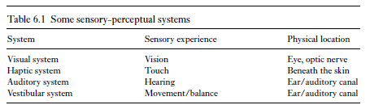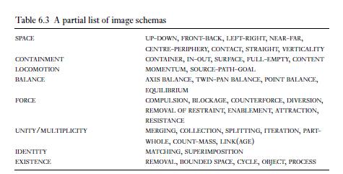

|  |  |  |
| --- | --- | --- |
| **Image Schema** | **situations for embodied experiences** | **sensory perceptual modalities** |
| Compulsion | being moved by external forces like wind, water, physical objects and other people | haptic system (touch, pressure on skin); vestibular system (balance, orientation); kinaesthesia (awareness of motion, externally initiated motion, inability to stop oneself from moving, directionality of motion, etc.) |
| Container |  |  |
| Near - Far |  |  |
| Process |  |  |
| Contact |  |  |

## Image Schemas and Metaphors (Chapter 6.2)

What are the image schemas that represent the source domain for the following examples?

1. He is very full of himself.
2. I really got into hot water with my criticism.
3. They ran into difficulty with their strategy.
4. The interest rates dropped again.
5. His ravings prove that he is totally unhinged.

## Frames (Chapter 7.1/2)

What do you associate with the following frames in cultural terms, as frame events where applicable ?

1. Fairytale
2. Vacation
3. Single (n)
4. teach (v)

## Prototypes (Chapter 8.2)

Which of the following would you rank as good, central examples and which ones as peripheral on a scale from 1 to 7 with 1 most central and 7 most peripheral?

buffalo, cat, chicken, dog, goat, goose, horse, pig, pigeon, rabbit, salmon, sheep, sika dear, trout

awl, circular saw, file, hammer, lathe, plane, power drill, riveting gun, sander, screwdriver, soldering iron, torque wrench, vice, wire brush

## Mappings (Chapter 9.2/3)

Based on the screenshot below, develop a similar table of mappings for Negotiation is War or Time is Space.

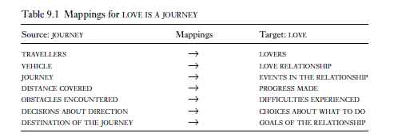

## Metaphors (Chapter 9.2-4)

Describe the following metaphors in terms of “A is B”. In addition, which ones would be primary and which ones would be compound metaphors

1. Studying during the pandemic has been a rough ride.
2. His grip on reality has weakend over the past months.
3. I was always closer to my mother than to my father.
4. English threatens many minority languages in the developing world.
5. Some small tribal language are about to become extinct.

## Metonymy (Chapter 9.5-7)

Find an example for metonymies in which

a) the part stands for the whole and b)

the whole stands for a part